
International School
Capstone Project 1
CMU-SE 450 – C1SE.06
Proposal
Version 2.1
Date: August 23, 2026
SFDS
Fraudulent Image Detection and Warning System with Explanations
Submitted by
Hao, Pham Tan
Nhung, Dao Thi My
Nam, Tran Hoang Nhat
Tuan, Nguyen Phan Duc
Approved by
Eng. Toan, Ha Manh
Proposal Review Panel Representative:
Name: ______________________ Signature: ________________ Date: ________
Capstone Project 1 - Mentor:
Name: Eng. Toan, Ha Manh Signature: ________________ Date: ________

PROJECT INFORMATION
Project acronym | SFDS
Project Title | Fraudulent image detection and warning system with explanations
Start Date | August 23, 2026 | End Date | December 22, 2026
Lead Institution | International School, Duy Tan University
Project Mentor | Eng. Toan, Ha Manh
Scrum Master / Project Leader & Contact | Hao, Pham Tan  Email: phamtanhao1909@gmail.com  Tel: 0961651933 | Student ID: 29219020823
Partner Organization | Duy Tan University
Team Members Contact Details:
Student ID | Full Name | Email Address | Phone Number
29219020823 | Hao, Pham Tan | phamtanhao1909@gmail.com | 0961651933
29209200048 | Nhung, Dao Thi My | mynhung150905@gmail.com | 0376415338
29219423638 | Nam, Tran Hoang Nhat | trannamnhathoang@gmail.com | 0795798736
29211151140 | Tuan, Nguyen Phan Duc | ductuan02072005@gmail.com | 0932442770
DOCUMENT NAME: PROPOSAL
Document Title | Proposal Document
Reporting Period | December 2026
Author(s) & Project | Hao, Pham Tan & Nhung, Dao Thi My
Date & File Name | August 23, 2026 | C1SE.06-Proposal_SFDS_v2.1.docx
REVISION HISTORY
Version | Date | Comments | Author | Approval
1.0 | August 22, 2026 | Initial Release | Hao, Pham Tan | Eng. Toan, Ha Manh
2.1 | August 23, 2026 | Synchronize with Multimodal Architecture, FastAPI, PhishVN and Complete Scope | Nhung, Dao Thi My | Eng. Toan, Ha Manh
DOCUMENT APPROVALS
The following signatures are required for approval of this document:
Member Name & Role | Signature | Date
Eng. Toan, Ha Manh - Project Mentor
Hao, Pham Tan (Student ID: 29219020823) - Scrum Master / Project Leader
Nhung, Dao Thi My (Student ID: 29209200048) - QA / UI-UX Designer
Nam, Tran Hoang Nhat (Student ID: 29219423638) - Frontend Developer
Tuan, Nguyen Phan Duc (Student ID: 29211151140) - Full-stack Developer / AI Lead

LIST OF CONTENTS
1. Project Title ........................................... 4
2. Team Members ............................................. 4
3. Supervisor ................................................. 4
4. Problem Statement ................................... 5
5. Survey / Existing Solutions ............... 5
6. Objectives and Scope ............................. 7
6.1. Objectives ....................................... 7
6.2. Scope (In-Scope and Out-of-Scope) 7
7. Key Features & Requirements ............... 8
7.1. Functional Requirements ............. 8
7.2. Non-Functional Requirements ..... 9
8. Constraints and Assumptions ............... 9
8.1. Constraints ..................................... 9
8.2. Assumptions ..................................... 10
9. Target Users / Stakeholders ............... 10
10. Technology Stack ................................... 11
11. Methodology & Development Plan ....... 12
11.1. Methodology ................................... 12
11.2. Development Plan (6 Sprints Overview) 13
11.3. Responsibilities ......................... 14
12. System Architecture Overview ........... 14
12.1. Layered Architecture ................. 14
12.2. System Context Diagram ............. 15
13. Potential Risks and Mitigation Strategies 16
14. Expected Outcomes / Deliverables ... 17
15. References ............................................... 18

1. Project Title
Fraudulent Image Detection and Warning System with Explanations (SFDS)

2. Team Members
Table 1: Team Members
Full Name | Student ID | Email | Assigned Role
Hao, Pham Tan | 29219020823 | phamtanhao1909@gmail.com | Project Leader, Full-stack Developer
Nhung, Dao Thi My | 29209200048 | mynhung150905@gmail.com | UI/UX Designer, QA/Tester, Documentation
Nam, Tran Hoang Nhat | 29219423638 | trannamnhathoang@gmail.com | Frontend Developer, Technical Writer
Tuan, Nguyen Phan Duc | 29211151140 | ductuan02072005@gmail.com | AI Engineer, Full-stack Developer

3. Supervisor
Table 2: Supervisor Information
Full Name | Eng. Toan, Ha Manh
Faculty / Department | International School - CMU, Duy Tan University
Email Address | lhttuy@gmail.com
Position / Title | Capstone Project 1 Academic Mentor

4. Problem Statement
In the current era of rapid digital transformation, online fraud and cyber deception in Vietnam have escalated into sophisticated, dangerous operations. Fraudsters systematically fabricate visual artifacts—such as fraudulent bank balance transfer receipts, bogus court summons or police arrest warrants, fake utility notices, deceptive employment recruitment banners, and counterfeit QR payment codes. These visual materials exploit psychological urgency and fear to manipulate victims into transferring money or disclosing confidential security credentials.
A critical limitation of existing security solutions is their 'black-box' nature: most scanners provide only a simplistic binary verdict ('Safe' or 'Scam') without providing clear explanations. Consequently, non-technical users cannot understand why an image is flagged as fraudulent or what immediate countermeasures they should undertake. Furthermore, conventional tools struggle with Vietnamese diacritics, localized scam linguistics, and multimodal fusion between visual manipulation and textual deceit.
To overcome these challenges, the team proposes developing the 'Scam Fraud Detection System with Explanations' (SFDS). SFDS integrates Vietnamese Tesseract OCR, visual image forensics (ELA/EXIF), PhishVN lexical URL analysis, and deep convolutional neural networks (ResNet-18) governed by a Multimodal Chain-of-Thought (CoT) reasoning engine. The system provides calibrated risk scores (0–100), transparent evidence decomposition, and contextual safety recommendations, empowering citizens and organizations to protect themselves against visual digital fraud.

5. Survey / Existing Solutions
A thorough survey of commercial platforms and academic research reveals four major categories of related solutions:
1. Google Lens / Microsoft Lens: Highly optimized for optical character recognition (OCR) and visual entity search across diverse languages. However, these tools are generic information retrieval engines; they lack fraud reasoning, banking invoice verification, and threat scoring.
2. Google Safe Browsing & ScamAdviser: Industry standards for web domain reputation and blacklist verification. While effective for live URLs, they cannot ingest image screenshots, analyze Vietnamese message semantics, or extract embedded QR codes.
3. VirusTotal: An aggregation scanner running multi-engine security checks for binaries and URLs. It provides comprehensive technical reports for security specialists but remains incomprehensible to regular consumers and lacks image-based multimodal inspection.
4. AI or Not: Specializes in detecting whether a digital image is AI-generated (Deepfake/GAN). While valuable for forensic media authentication, it is not tailored to cyber-fraud heuristics, fake invoices, or localized Vietnamese phishing campaigns.
Table 3: Comparison between Existing Solutions and Proposed SFDS System
Key Capability / Feature | Google Lens | SafeBrowsing | VirusTotal | AI or Not | Proposed SFDS
Vietnamese OCR Text Extraction | + | - | - | - | +
Multi-source Input (Image, QR, Text, PDF) | △ | - | - | - | +
Malicious URL Lexical Analysis (PhishVN) | - | + | + | - | +
Image Manipulation Forensics (EXIF/ELA) | - | - | - | + | +
Calibrated Risk Score & Level (0-100) | - | + | △ | - | +
Explainable Reasoning & Actionable Advice | - | - | - | - | +
Note: +: Fully Supported; △: Partially Supported; −: Not Supported.

6. Objectives and Scope

6.1. Objectives
The overarching objective of the SFDS project is to build an accessible, explainable, and scientifically validated detection platform for Vietnamese fraudulent visual media. The specific academic and engineering objectives comprise:
• Multi-modal Threat Classification: Accurately classify fraudulent images across 4 primary taxonomies: fake banking transaction bills, government authority impersonation notices, SMS/chat phishing screenshots, and fraudulent QR code payments.
• Explainable AI (XAI) Synthesis: Provide transparent, decomposed explanations breaking down risk origins (text semantic keywords, lexical URL risks, visual tampering indicators, and model layout probabilities).
• Objective Evaluation Metrics: Evaluate detection efficacy on independent test datasets using Character Error Rate (CER) & Word Error Rate (WER) for Vietnamese OCR, and Macro-F1, Recall, False Alarm Rate, and Explanation Usefulness (EU) score for scam classification.

6.2. Scope
In-Scope:
• Multi-source Scanning: Ingest images (JPG, PNG, WEBP, BMP), QR codes embedded in images, raw pasted text/SMS messages (up to 20,000 characters), and multi-page PDF documents (up to 10 pages / 15MB).
• Image Forensics & Processing: Extract text via Tesseract OCR with Vietnamese language models; compute Error Level Analysis (ELA) and inspect EXIF metadata.
• Machine Learning Models: HistGradientBoosting model trained on PhishVN v3.1.0 (21 lexical features) and fine-tuned ResNet-18 convolutional neural network.
• Soft Consensus Risk Engine: Compute calibrated risk score (0–100) mapped into 3 safety tiers: Safe (0–25), Suspicious (26–59), and Dangerous (60–100).
• Guest Inspection & Admin Portal: Allow instant guest inspection with local browser history (up to 50 scans via localStorage); authenticated administrative portal for training datasets, model checkpoints, evaluations, and audit logs.
• Interactive Safety Assistant: Context-aware conversational guidance answering post-scan remediation inquiries.
Out-of-Scope:
• Real-time video stream, deepfake video generation, and live telecommunication audio/voice call analysis.
• Direct automated reporting to banking gateways or law enforcement criminal filing.
• Native mobile client applications (the scope of Capstone Project 1 is strictly responsive Web Application).

7. Key Features & Requirements

7.1. Functional Requirements
Table 4: Functional Requirements (FR)
Req ID | Requirement Title | Detailed Functional Description
FR01 | Multi-source Ingestion | System allows users to upload images (JPG/PNG/WEBP/BMP), paste raw text, input URLs, and upload PDF documents for analysis.
FR02 | OCR & QR Processing | Extracts Vietnamese text using Tesseract OCR (vie.traineddata) and decodes payment/URL QR codes embedded within images.
FR03 | PhishVN URL Analysis | Parses extracted URLs, extracts 21 lexical features, and evaluates phishing probabilities via HistGradientBoosting.
FR04 | Visual Image Forensics | Executes Error Level Analysis (ELA) and extracts EXIF camera metadata to detect composite digital manipulation.
FR05 | Risk Score & Decomposed XAI | Computes calibrated risk score (0-100) and displays decomposed signal breakdown (Text, URL, Visual, Model).
FR06 | Interactive Safety Assistant | Provides contextual safety guidelines and interactive Q&A answering remediation queries based on scan findings.
FR07 | Privacy-first Guest History | Stores up to 50 recent inspection reports locally on user's browser (localStorage) without mandatory user account creation.
FR08 | Admin Governance Portal | Enables authenticated administrators (JWT) to manage training datasets, AI model checkpoints, evaluation metrics, and audit logs.

7.2. Non-Functional Requirements
Table 5: Non-Functional Requirements (NFR)
NFR ID | Quality Attribute | Measurable Specification Target
NFR01 | Performance & Latency | End-to-end image processing (OCR, URL analysis, model inference) must respond within 3.0 seconds under normal payload.
NFR02 | Security & Upload Safety | Strict validation of file magic bytes (python-magic), blocking malicious scripts, enforcing 15MB file size ceiling, and JWT auth for admin.
NFR03 | Data Privacy & Anonymity | Guest uploads are analyzed in temporary isolated storage; sensitive customer banking logs are not stored without consent.
NFR04 | Scalability & Modular AI | System supports hot-swapping or fine-tuning of machine learning checkpoints (PhoBERT, ResNet) without altering REST API schema.
NFR05 | Usability & Accessibility | Clean responsive interface compliant with WCAG 2.1 accessibility; color-coded risk alerts (Green, Yellow, Red) with clear Vietnamese copy.

8. Constraints and Assumptions

8.1. Constraints
Table 6: Project Constraints
Category | Constraint Description | Guidelines for Acceptance
Time & Schedule | Project must be completed within 16 calendar weeks (93 working days) across 6 Scrum Sprints. | Weekly sprint tracking on Jira; burn-down velocity reviews with mentor.
Tool / Technology | Standardized on Python (FastAPI), React, PyTorch, Scikit-Learn, and Docker. | Tools must run cross-platform and support containerized staging deploy.
Hardware & GPU | Inference must execute efficiently on commodity CPU/RAM or cloud instances (AWS EC2 t3.medium). | Inference models must maintain memory footprint below 2.0 GB.
Dataset Privacy | All Vietnamese scam samples must be anonymized before inclusion in benchmark sets. | Scrub PII (Personally Identifiable Information) including names and real phone numbers.
Economic Budget | Student budget cap of under $350 USD for external hosting, domain, and compute. | Prioritize open-source libraries, local workstation training, and AWS Free Tier.

8.2. Assumptions
• Users possess stable internet connectivity to upload media and view analysis dashboards.
• Uploaded images retain sufficient resolution (at least 300x300 pixels) to permit OCR font segmentation.
• Benchmark datasets (PhishVN v3.1.0) and synthetically generated Vietnamese invoices provide statistically representative samples for evaluation.
• Administrators hold valid credentials to operate model deployments and inspect system audit trails.

9. Target Users / Stakeholders
Table 7: Stakeholders and Direct Benefits
Stakeholder Group | Direct Project Benefits
End Users / General Public | • Easily inspect suspicious images, bills, SMS messages, and QR codes without account barriers.  • Receive intuitive, transparent risk scores and localized explanations.  • View highlighted evidence on canvas and obtain actionable immediate countermeasures.  • Maintain local browser inspection history without privacy leakage.
System Administrators & Analysts | • Govern AI model checkpoints, evaluate dataset performance, and review system audit logs.  • Manage dynamic keyword scoring dictionaries without redeploying application code.  • Monitor system health, API latency, and threat distribution statistics.

10. Technology Stack
Table 8: Synchronized Technology Stack
System Component | Selected Technology | Architectural Role & Purpose
Frontend UI | React (Vite), JavaScript, CSS3 | High-performance Single Page Application (SPA), responsive inspection dashboard, and canvas highlighting.
Backend Web API | Python 3.12, FastAPI, Uvicorn | Asynchronous high-throughput REST API gateway, OpenAPI auto-docs (/docs), and request validation.
Database Engine | SQLite (Local/Dev) & MySQL 8.0 | Hybrid persistence: zero-config SQLite for local demo/testing; MySQL schema for production and admin records.
ORM Framework | SQLAlchemy 2.0 | Object-relational mapping, database connection pooling, and schema migration.
AI / OCR Engine | Tesseract OCR (tessdata/vie) | Optical character recognition optimized for accented Vietnamese text and banking receipt layouts.
AI / URL Scanner | PhishVN (HistGradientBoosting) | Extracts 21 lexical features from URLs to infer phishing probabilities using pre-trained models.
AI / Visual Classifier | PyTorch, ResNet-18 fine-tuned | Convolutional neural network for layout and counterfeit image classification.
Visual Forensics | OpenCV, Pillow (ELA & EXIF) | Error Level Analysis (ELA) for image resaving traces, JPEG compression artifacts, and metadata checks.
DevOps & Testing | Docker, Docker Compose, Pytest | Isolated containerization for microservices, automated regression test suites, and GitHub Actions CI/CD.

11. Methodology & Development Plan

11.1. Methodology
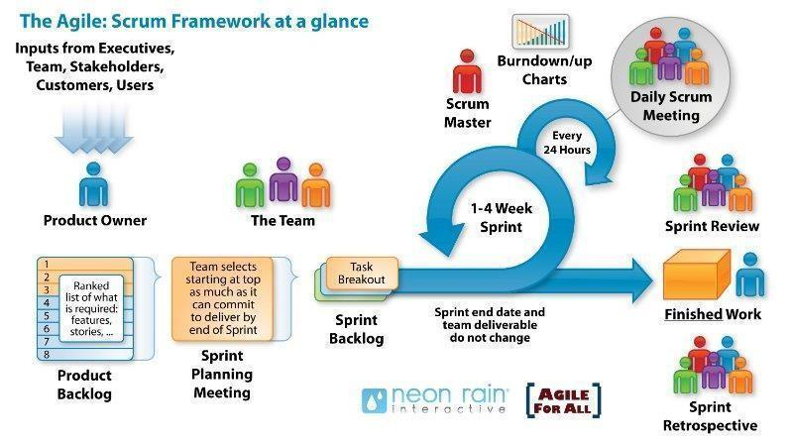
Figure 1: Scrum Agile Framework
The project utilizes the Agile Scrum Framework, structuring the development lifecycle into short, iterative 14-day Sprints. This methodology is particularly advantageous for AI-assisted engineering where data distributions, OCR edge cases, and machine learning thresholds require continual empirical calibration.

11.2. Development Plan
Table 9: Schedule Overview (6 Sprints Breakdown)
No. | Sprint / Milestone Name | Duration | Start Date | Finish Date | Effort (Hrs)
1 | Sprint 1: Architecture, DB Schema & Baseline Setup | 14 days | 02/09/2026 | 16/09/2026 | 200
2 | Sprint 2: OCR Engine, PhishVN & Risk Base Engine | 14 days | 17/09/2026 | 01/10/2026 | 200
3 | Sprint 3: Visual Forensics, Explanations & Multi-input | 14 days | 02/10/2026 | 16/10/2026 | 200
4 | Sprint 4: Admin Portal, Dynamic Rules & Security | 14 days | 17/10/2026 | 31/10/2026 | 200
5 | Sprint 5: Model Evaluation, Dockerizing & Optimization | 14 days | 01/11/2026 | 15/11/2026 | 200
6 | Sprint 6: User Acceptance Testing (UAT) & Staging Deploy | 15 days | 16/11/2026 | 01/12/2026 | 200
7 | Final Adjustments & Technical Report Documentation | 16 days | 02/12/2026 | 18/12/2026 | 200
8 | Project Retrospective & Mock Defense Meeting | 2 days | 18/12/2026 | 20/12/2026 | 10
9 | Official Capstone Project 1 Final Defense | 1 day | 22/12/2026 | 22/12/2026 | 15
 | TOTAL CUMULATIVE ENGINEERING EFFORT | 93 days | 02/09/2026 | 22/12/2026 | 1,425 hrs

11.3. Responsibilities
Table 10: Team Member Role Allocation
Member Name | Core Responsibilities
Hao, Pham Tan | Project Leader, Scrum Master, Backend Developer (FastAPI, MySQL, Docker, System Integration).
Nhung, Dao Thi My | QA Lead, UI/UX Designer, Test Case Engineering, UAT Coordination, Technical Documentation.
Nam, Tran Hoang Nhat | Frontend Developer (React, Vite, CSS3, Canvas Bounding Box, LocalStorage History).
Tuan, Nguyen Phan Duc | AI Lead, Full-stack Developer (Tesseract OCR, PhishVN, ResNet-18, Model Benchmark Evaluation).

12. System Architecture Overview

12.1. Layered Architecture
The SFDS system implements a decoupled 4-tier microservice architecture ensuring high maintainability and security:
1. Presentation Layer (React Client): Provides an intuitive single-page application supporting drag-and-drop file ingestion, real-time bounding box highlighting, and localized inspection history management.
2. API Gateway & Application Layer (FastAPI): Manages RESTful routing, payload validation (magic byte checks), rate limiting, and role-based access control (RBAC via JWT).
3. Analytical & Machine Learning Layer: Houses the specialized detection sub-engines: Tesseract OCR, PhishVN URL classifier, ResNet-18 visual network, OpenCV ELA forensics, and the Multimodal CoT Reasoning Engine.
4. Persistence & Cache Layer: Manages structured transactional data in MySQL, session caching in Redis, and client-side history in browser localStorage.

12.2. System Context Diagram
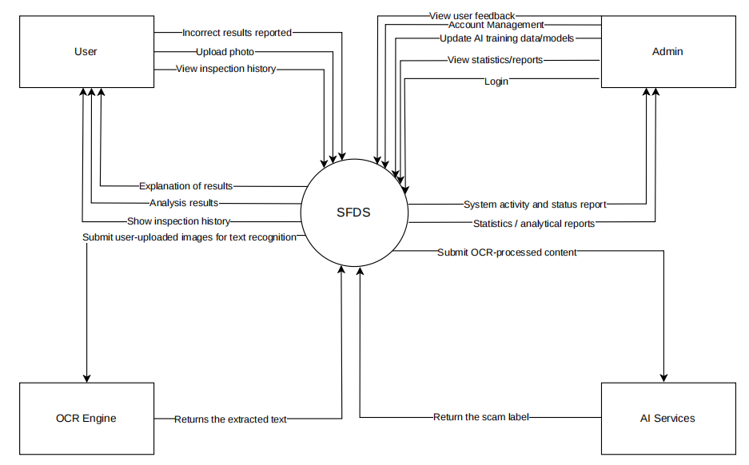
Figure 2: System Context Diagram (SFDS Interactions)

13. Potential Risks and Mitigation Strategies
Table 11: Risks and Mitigations Matrix
No. | Risk Title | Risk Description | P | I | E | Mitigation Strategy
1 | Security Vulnerabilities | Risks of arbitrary file upload, API parameter manipulation, or unauthorized administrative access. | 3 | 5 | 15 | Inspect magic bytes (python-magic), disallow script extensions, enforce role-based JWT auth, and isolate uploads.
2 | Project Schedule Slippage | Development delays caused by complex AI model calibration or mid-semester academic workload. | 4 | 4 | 16 | Divide work strictly into 14-day sprints, monitor daily Jira velocity, and prioritize core functionality over optional extras.
3 | Server Performance Under Peak | Concurrent image OCR and deep learning inference causing memory spikes or high API response latency. | 3 | 4 | 12 | Implement background task queues (Celery/Redis), rate limiting, and deploy lightweight quantized inference checkpoints.
4 | Data Privacy & Sensitive PII | Uploaded receipts containing real victim names, bank accounts, or sensitive identity cards. | 3 | 5 | 15 | Store guest scans on client localStorage; scrub personal numbers from benchmark datasets; implement automated scratch cleanup.
5 | AI False Positives / Negatives | Model misclassifies legitimate banking receipts or misses novel deceptive layouts. | 4 | 5 | 20 | Use Soft Consensus Fusion instead of raw max, calibrate decision thresholds on 200+ clean bills, and provide transparent explanations.
6 | Cloud Hosting Cost Overrun | Continuous AWS EC2 and GPU usage exceeding the allocated student project budget. | 3 | 3 | 9 | Perform training on local workstations/Colab; deploy lightweight models (ResNet-18); run EC2 only during staging demo intervals.

14. Expected Outcomes / Deliverables
• Complete Software Application: A fully functional, responsive web application supporting multi-source scanning (Image, Text, URL, QR, PDF) with explainable risk breakdown and interactive safety guidance.
• Source Code Repository: Clean, well-documented source code for the React frontend, FastAPI backend, and AI/ML pipelines with Git version control.
• Technical Engineering Documentation: Comprehensive Software Requirements Specification (SRS), Software Design Document (SDD), and API documentation via Swagger/OpenAPI.
• Vietnamese Scam Benchmark Dataset: Curated, anonymized dataset of labeled Vietnamese scam images, fake invoices, and phishing URLs.
• Scientific AI Benchmark Report: Documented evaluation results measuring Character Error Rate (CER), Word Error Rate (WER), Macro-F1, Recall, False Alarm Rate, and Explanation Usefulness.
• User & Admin Manuals: Step-by-step illustrated operational guides for general users and system administrators.

15. References
Table 12: Academic & Technical References
No. | Reference Topic | Source Citation & Online Documentation
1 | Scrum Agile Framework | Schwaber, K. & Sutherland, J. (2020). The Scrum Guide. https://www.scrum.org/
2 | Vietnamese Phishing Dataset | Nguyen, H. et al. (2024). PhishVN: A Time-Stamped Vietnamese URL Phishing Dataset. Mendeley Data.
3 | FastAPI Framework | Tiangolo, S. (2024). FastAPI: High performance, easy to learn, fast to code. https://fastapi.tiangolo.com/
4 | React Framework | Meta Platforms, Inc. (2024). React: The library for web and native user interfaces. https://react.dev/
5 | Tesseract OCR | Smith, R. (2007). An Overview of the Tesseract OCR Engine. IEEE ICDAR. https://tesseract-ocr.github.io/
6 | Deep Residual Learning | He, K., Zhang, X., Ren, S., & Sun, J. (2016). Deep Residual Learning for Image Recognition. IEEE CVPR.
7 | Software Engineering Standards | ISO/IEC/IEEE 12207:2017 Systems and software engineering - Software life cycle processes.

